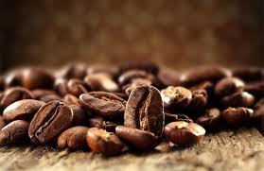 | Coffee gathering (café-rencontre)  Frequency: twice a month  Duration: 2-3 hours  Format: coffee served with muffins, cupcakes and/or cookies  When: to be determined  Price: based on what you eat and drink | Would you be interested?  YES NO
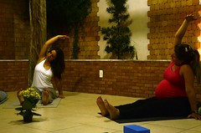 | Yoga class  Frequency: once a week  Format: courses  Duration: 1 hour  When: evening from 7 to 8 p.m.  Price: between $10 and $15 | Would you be interested?  YES NO
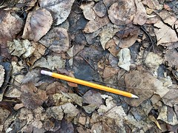 | Literary or poetic creation workshop  Frequency: twice a month  Duration: 2 hours  Format: facilitated workshop  A song, a poem, a short story, the beginning of a novel? Bring your project and work on it; discuss and exchange; every month, read an excerpt of your creation (on a voluntary basis).  When: evening from 7 to 9 p.m.  Price: between $10 and $15 | Would you be interested?  YES NO
 | Book Club  Frequency: once a month  Duration: between 2 and 3 hours  Format: discussion in a circle and voluntary intervention  When: evening from 7 to 9 p.m.  Price: to be determined | Would you be interested?  YES NO
 | Knitting and crochet club  Frequency: once a week  Duration: 2 hours  Format: bring your project  When: in the afternoon or evening  Price: between $3 and $5 | Would you be interested?  YES NO
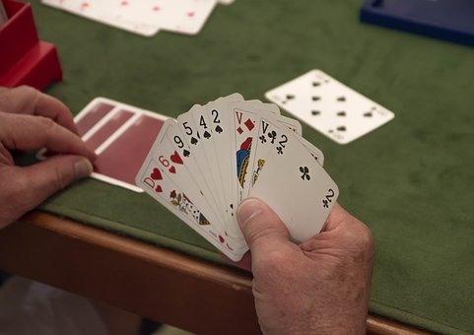 | Bridge course for beginners or intermediates  Frequency: once a week  Duration: 1 hour or 2 hours  Format: course  When: in the afternoon or evening  Price: between $10 and $15 | Would you be interested?  YES NO
 | Board games  Frequency: once a week  Duration: between 2 and 3 hours  Format: bring a board game, form a group, and play!  When: in the afternoon or evening  Price: between $3 and $5 | Would you be interested?  YES NO
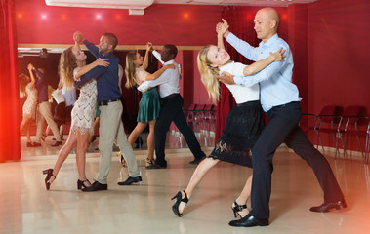 | Dance Classes – Tango  Frequency: once a week  Duration: 1 or 2 hours  Format: courses  When: in the afternoon or evening  Price: between $10 and $15 | Would you be interested?  YES NO
 | Dinner with neighbours and friends  Frequency: once a month  Duration: 3 hours  Format: bring a dish  When: evening from 6 to 9 p.m.  Price: between $3 and $5 | Would you be interested?  YES NO
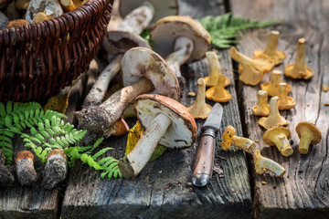 | Course on wild mushroom recognition (mycology)  Frequency: once a month  Duration: 1 hour  Format: course  When: evening from 7 to 8 p.m.  Price: between $10 and $15 | Would you be interested?  YES NO
 | Additional ideas  Course on medicinal plants?  Conferences on history?  Vegetarian cooking classes?  Etc. | Do you have any suggestions? Commentaries?  Please, let us know.

